**Lab Exercise 2**

**IT4030 –Internet of Things (IoT) 2024**

**Lab 2: Controlling the servo motor by using the ultrasonic sensor**

Objectives:

* Studying about the ultrasonic sensor and servo motor
* Creating a circuit in Tinkercad to control the servo motor by using the ultrasonic sensor

Background:

An **ultrasonic sensor** is an electronic device that measures the distance to a target object from it by emitting ultrasonic sound waves and then it converts the reflected sound into an electrical signal. **HC-SR04** is a type of an ultrasonic sensor that can measure a distance ranging from 2cm up to 400cm with a ranging accuracy that can reach up to 3mm. There are four pins in this sensor: VCC, Trig (signal output pin), Echo (signal input pin) and GND. The HC-SR04 ultrasonic sensor is shown in Figure 1.



**B**

**Sc in**

**Information Technology**

**Year 4**

**-**

**Semester 1**

**/2**

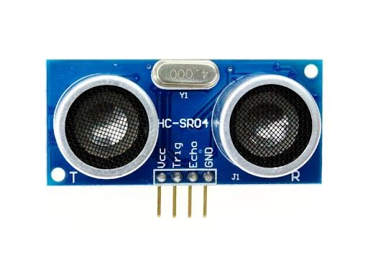

*Figure*

*1*

*:*

*HC*

*-*

*SR04*

*Ultrasonic*

*sensor*

A **servo motor** is a rotary actuator or linear actuator that allows for precise control of angular or linear position, velocity and acceleration. An object can be rotated to a specific angle by using a servo motor. A servo motor is depicted in Figure 2.

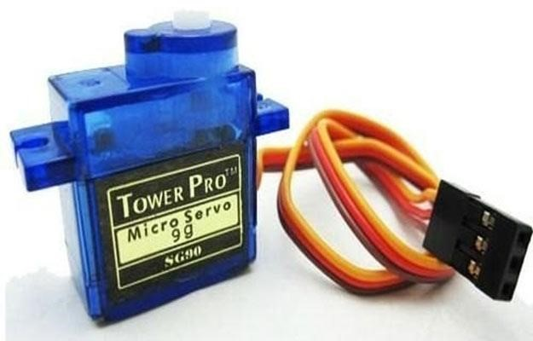

*Figure 2 : Servo motor*

1

Procedure:

1. Using Tinkercad, create the circuits and use the codes given in each part of the labsheet.

# Part 1 : Connecting an ultrasonic sensor to the Arduino

## Circuit

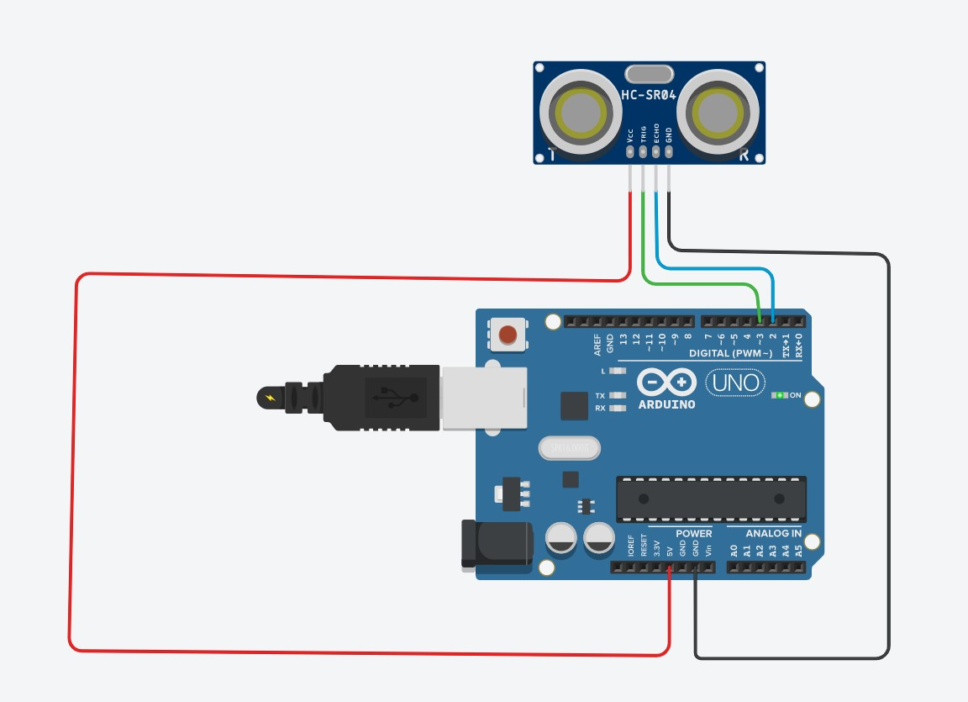

## Code

int trigger_pin = 3; int echo_pin = 2; int time;

int distance;

void setup ( ) {

Serial.begin (9600);

pinMode (trigger_pin, OUTPUT); pinMode (echo_pin, INPUT);

}

void loop ( ) {

digitalWrite (trigger_pin, HIGH); delayMicroseconds (10); digitalWrite (trigger_pin, LOW); time = pulseIn (echo_pin, HIGH); distance = (time * 0.034) / 2;

Serial.print (" Distance= ");

Serial.println (distance);

}

# Part 2 : Connecting a servo motor to the Arduino

## Circuit

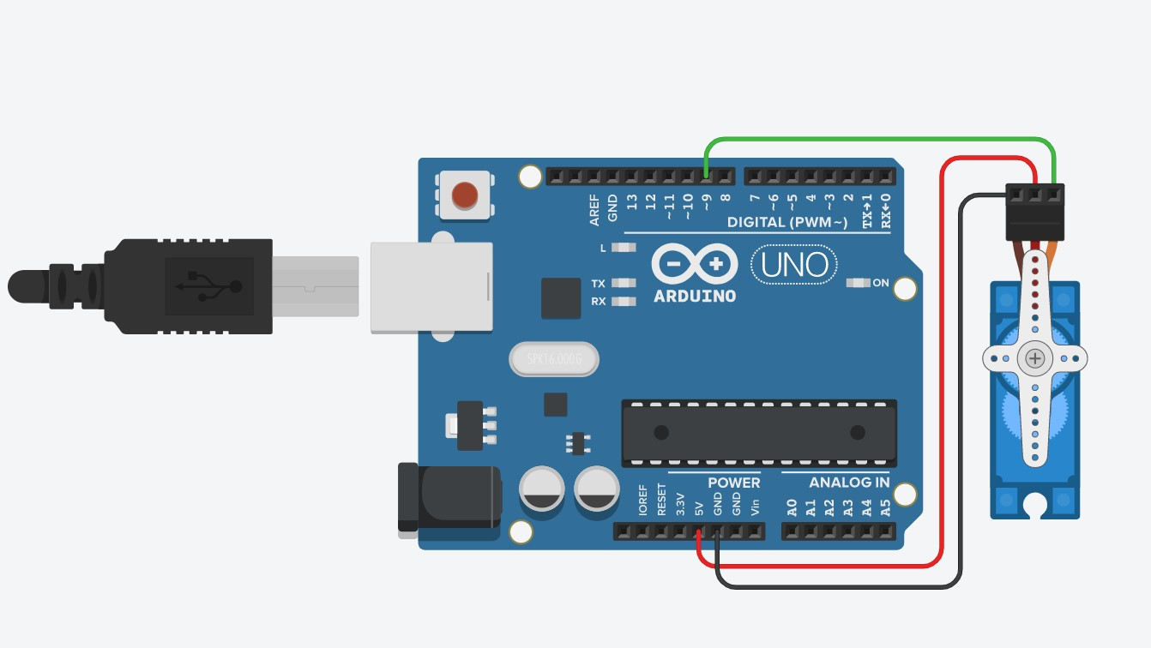

**Video**



## Code

#include <Servo.h>

int pos = 0;

Servo servo_9;

void setup()

{

servo_9.attach(9, 500, 2500);

}

void loop()

{

for (pos = 0; pos <= 180; pos += 1) { servo_9.write(pos);

delay(15); // Wait for 15 millisecond(s)

}

for (pos = 180; pos >= 0; pos -= 1) { servo_9.write(pos);

delay(15); // Wait for 15 millisecond(s)

}

}

# Part 3 : Controlling the servo motor by using the ultrasonic sensor

## Circuit

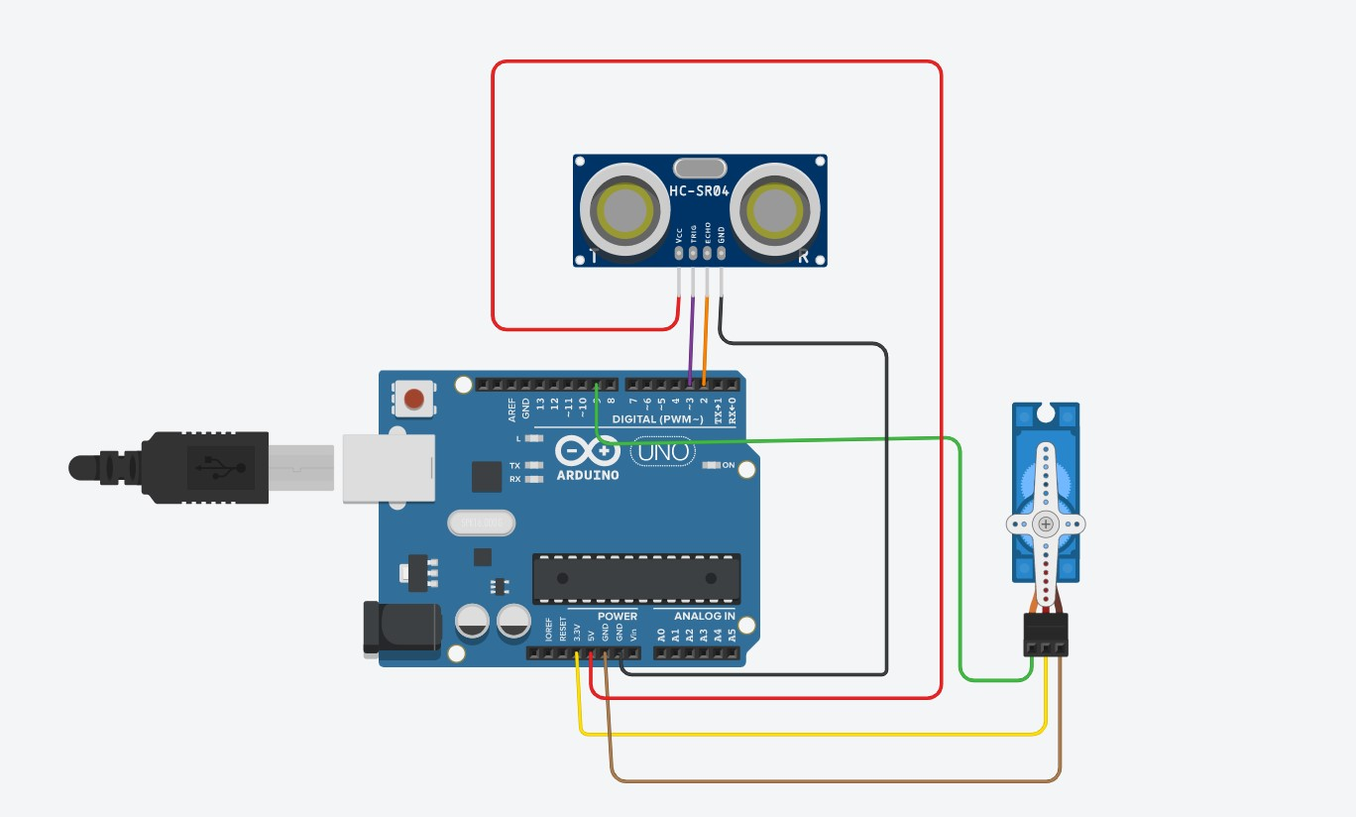

**Video**



## Code

#include <Servo.h>

int trigger_pin = 3; int echo_pin = 2; int time;

int distance;

Servo servo_9;

int pos;

void setup ( ) {

Serial.begin (9600);

pinMode (trigger_pin, OUTPUT); pinMode (echo_pin, INPUT); servo_9.attach(9);

}

void loop ( ) {

digitalWrite (trigger_pin, HIGH); delayMicroseconds (10); digitalWrite (trigger_pin, LOW); time = pulseIn (echo_pin, HIGH); distance = (time * 0.034) / 2;

if (distance <= 100)

{

Serial.println (" Door Open ");

Serial.print (" Distance= "); Serial.println (distance); delay (500); servo_9.write(180);

delay(15);

}

else {

Serial.println (" Door closed ");

Serial.print (" Distance= "); Serial.println (distance); delay (100);

}

}